

GUIDELINES FOR NOTIFICATION OF VETERINARY MEDICAL DEVICES AND IN VITRO DIAGNOSTIC DEVICES

JANUARY, 2026

FOREWORD

Rwanda Food and Drugs Authority (Rwanda FDA) is a regulatory body established by Law N° 003/2018 of 09/02/2018. One of the functions of Rwanda FDA is to regulate matters related to the quality, safety, and performance of veterinary medical devices and in vitro diagnostic devices (IVDDs) to protect public health by increasing access and availability.

In consideration of the provisions of the regulation No. DFAR/HMDAR/TRG/002 Rev_2 governing the registration of medical devices, including IVDDs. Rwanda FDA has developed these guidelines for the Notification of veterinary medical devices and IVDDs.

These guidelines were developed in reference to the Regulation on Harmonization in the East African Community (EAC) and the International Medical Devices Regulators Forum (IMDRF), formerly known as Global Harmonization Task Force (GHTF).

The purpose of these guidelines is to provide requirements for notification of veterinary medical devices and IVVDs to assess the conformity of such products to the essential principles of safety and performance, and upon notification acceptance, a letter of approval of notification shall be issued. They also provide the content and format of information to be presented.

Adherence to the guidelines by the manufacturers/applicants will facilitate the Rwanda FDA to timely assess and approve notified medical device and IVDDs dossiers for a letter of notification.

Rwanda FDA acknowledges all stakeholders who participated in the development, review, and validation of these guidelines.

Prof. Emile BIENVENU
Director General

DOCUMENT DEVELOPMENT HISTORY

First issue date | Refer to the approval date
Effective date of this revision | Refer to the approval date

DOCUMENT REVISION HISTORY

Date of revision | Version number | Changes made and/or reasons for revision
- | 1 | First issue

TABLE OF CONTENTS

FOREWORD 2
DOCUMENT DEVELOPMENT HISTORY 3
DOCUMENT REVISION HISTORY 3
TABLE OF CONTENTS 4
LIST OF TABLES 5
ACRONYMS AND ABBREVIATIONS 6
GLOSSARY / Definitions 7
CHAPTER I: INTRODUCTION 11
I.1. Background 11
I.2. Scope 11
I.3. General principles 12
I.4. Submission of Application 12
CHAPTER II: Application Requirements 13
II.1. Requirements for notification of new applications 13
II.1.1. Administrative information requirements 13
II.1.2 Technical Documentation Requirements 13
II.2 Receiving Applications for Medical Devices Registration/Notification 13
II.3 Dossier Assessment Procedures 13
II.3.1. Dossier Notification Procedure 13
II.4. Authority’s Internal Scientific Review Committee for Medical Device Registration 14
II.5. Letter of approval for notification of Veterinary Medical Devices and In Vitro Diagnostics 14
II.6 Timelines for Medical Devices Notification 14
II.6.1. Timelines for notification of new applications 14
II.6.2 Classification of Medical Devices 15
1.12. II.7 Compliance with the Quality Management System (QMS) 16
References: 16
ENDORSEMENT OF THE GUIDELINES 17
ANNEXES 18
Annex I: Cover Letter 19
Annex II: Notification Application Form of Veterinary Medical devices and /or In Vitro Diagnostics Devices (IVDD). Error! Bookmark not defined.
Annex III: Medical Device Classification Rules. 22
Annex IV: Classification rules of In-vitro diagnostics devices 36
Annex V: Contents of veterinary medical device and/or IVDD description, instruction for use, device labels, device art work; product leaflet or catalogue 40
Annex VI: Letter of approval notification of Veterinary Medical Devices and In Vitro Diagnostics 44

LIST OF TABLES

Table 1: Classification for Medical Devices and/or IVDD 11
Table 2: Classification examples for Medical Devices 15

ACRONYMS AND ABBREVIATIONS

CE : | Conformité Européenne
COA: | Certificate of Analysis
GDL: | Guideline
GDP: | Good Distribution Practice
GMP: | Good Manufacturing Practices.
IEC: | International Electrotechnical Commission
ISO: | International Organization for Standardization.
IVDDs: | In-Vitro Diagnostics Device.
ME: | Medical Electrical.
PEMS: | Programmable Electrical Medical Systems.
Rwanda FDA: | Rwanda Food and Drugs Authority
VICH: | International Cooperation on Harmonisation of Technical Requirements for Registration of Veterinary Medicinal Products.
VMDR: | Veterinary Medicine Registration Division
ISRC : | Internal Scientific Review Committee

GLOSSARY / Definitions
For the purpose of these guidelines, the following definitions shall apply:

“A certificate of conformity (CoC)” is issued by an authorized party (sometimes the manufacturer, sometimes an independent laboratory) and states that the device/product meets the required standards or specifications.

“Accessory to IVDD” means an article intended specifically by its manufacturer to be used together with a particular IVD device to enable or assist that device to be used in accordance with its intended use.

“Active medical device” means any medical device that depends on a source of electrical energy or any source of power other than that directly generated by the animal/human body or gravity and which acts by converting this energy. Medical devices intended to transmit energy, substances, or other elements between an active medical device and the patient, without any significant change, are not considered to be active medical devices. Standalone software is considered to be an active medical device.

“Applicant” means the person by, or on whose behalf, an application for, an update or amendment to an existing registration, is made. After the product is registered, the applicant shall be the “Marketing Authorization Holder”.

“Authority” means Rwanda Food and Drugs Authority or its acronym “Rwanda FDA”, established under Law N0. 003/2018 of 09/02/2018.

“Batch number (or lot number)” a distinctive combination of numbers and/or letters which specifically identifies a batch on the labels, the batch records etc.

“Certificate of Registration (Market Authorization)” means a certificate issued by the authority after its approval to market and sell the device in Rwanda; applicable to medical devices and IVD devices that are specifically intended by the manufacturer to be used in only animal healthcare and must be labeled on device label (s), Mock-ups and manual “Veterinary use only/ for animal use only”.

“Conformity Assessment Body (CAB)” means a body, other than a regulatory authority, engaged in determining whether the relevant requirements in technical regulations or standards are fulfilled.

“Conformity Assessment” The systematic examination of evidence generated and procedures undertaken by the manufacturer, under requirements established by the Authority, to determine that veterinary medical devices, including an IVDD is safe and performs as intended by the manufacturer and, therefore, conforms to the Essential Principles of Safety and Performance of Medical Devices.

“Documentation” a compilation of required information for registration including samples and any other additional information requested for registration.

“Fee” means the fee prescribed in relevant regulation governing service tariff/fees and charges at the time of dossier submission.

“Implantable device” means any device which is intended: to be totally introduced into the animal body or, to replace an epithelial surface or the surface of the eye, by surgical intervention which is intended to remain in place after the procedure. Any device intended to be partially introduced into the animal/human body through surgical intervention and intended to remain in place after the procedure for at least 30 days is also considered an implantable device.

“Intended use/purpose” The objective intent of the manufacturer regarding the use of a device, process or service as reflected in the specifications, instructions and information provided by the manufacturer.

“Invasive device” A device, which, in whole or in part, penetrates inside the body, either through a body orifice or through the surface of the body. Body orifice means any natural opening in the body, as well as the external surface of the eyeball, or any permanent artificial opening, such as a stoma or permanent tracheotomy.

“In-vitro diagnostic device (IVDD)” A device, whether used alone or in combination, intended by the manufacturer for the in vitro examination of specimens derived from the animal body solely or principally to provide information for diagnostic, monitoring, or compatibility purposes. This includes reagents, calibrators, control materials, specimen receptacles, software, and related instruments or apparatus or other articles.

Note: IVD devices include reagents, calibrators, control materials, specimen receptacles, software, and related instruments or apparatus or other articles and are used, for example, for the following test purposes: diagnosis, aid to diagnosis, screening, monitoring, predisposition, prognosis, prediction, determination of physiological status.

“IVD test kit” an IVD test kit is an in vitro diagnostic Device (IVDD) that consists of reagents or articles that are from the same manufacturer; intended to be used in combination to complete a specific intended purpose; sold under a single test kit name or the labelling, instructions for use (IFU), brochures or catalogues for each reagent or article states that the component is intended for use with the IVD test kit; and compatible when used as a test kit.

Note: An IVD test kit does not include the instruments, such as analyzers needed to perform the test.

“Label” means any tag, brand, mark, pictorial or other descriptive matter, written, printed stenciled, marked, embossed or impressed on or attached to a container of any medical devices or IVDDs and includes an informational sheet or leaflet that accompanies the medical devices or IVDD when its being supplied.

“Labelling” is all label and other written, printed, or graphic matter (l) upon any article or any of its containers or wrappers, or (2) accompanying such article" at any time while a device is held for sale after shipment or delivery for shipment in interstate commerce (This excludes shipping documents).

“Law” means Law N0 003/2018 of 09/02/2018 establishing the Rwanda FDA and determining its mission, organization and functioning.

“Local Technical Representative (LTR)” means any corporate body registered in Rwanda and authorized by Rwanda FDA to deal with Veterinary Medical Devices and IVDDs that has received a mandate from the Applicant to act on his/her behalf about matters pertaining to the registration of veterinary medical devices and IVDDs.

“Manufacture” means all operations that involve preparation, processing, filling transforming, packaging, repackaging and labelling of medical devices and/or IVDD.

“Manufacturer” means a person or a firm that is engaged in the manufacture of medical devices or IVDDs.

“Marketing Authorization holder” means a company which holds an authorization to place a medical device on the Rwandan market and is responsible for that device.

“Marketing authorization/ Notification, Registration certificate” means a legal document issued by the competent authority for the purposes of marketing or free distribution of a product which has been approved after evaluation for safety, quality and performance.

“Medical device family” means a group of medical devices that are made by the same manufacturer, that differ only in shape, colour, flavor, or size, that have the same design and manufacturing process, and that have the same intended use.

“Medical device group family” means a collection of medical device groups that are made by the same manufacturer, that have the same generic name specifying their intended use and that differ only in the number and combination of products that comprise each group.

“Medical device group” means a group of devices comprising a collection of medical devices, such as a procedure pack or tray, that is sold under a single name.

“Medical Device System” A medical device comprising a number of components or parts

“Medical device” means any instrument, apparatus, implement, machine, appliance, implant, software, material or other similar or related article, intended by the manufacturer to be used, alone or in combination, for human beings or animals, for one or more of the specific medical purpose(s) of diagnosis, prevention, monitoring, treatment or alleviation of disease; diagnosis, monitoring, treatment, alleviation of or compensation for an injury; investigation, replacement, modification or support of the anatomy or a physiological process; supporting or sustaining life; control of conception; disinfection of medical devices; providing information by means of in vitro examination of specimens derived from the human or animal bodies, and which does not achieve its primary intended action by pharmacological, immunological or metabolic means, in or on the human or animal body, but which may be assisted in its intended function by such means.
intended to be used together to fulfil some or the entire device’s intended functions and that is sold under a single name.

“Medical Devices with Measuring Function” a device has a measuring function if;
  - The device is intended by the manufacturer to measure: - quantitatively a physiological or anatomical parameter, or - a quantity or a qualifiable characteristic of energy or of substances delivered to or removed from an animal body,
  - The result of the measurement - is displayed in legal units or other internationally acceptable units or - is compared to at least one point of reference indicated in legal units or other acceptable units.
  - The intended purpose implies accuracy, claimed explicitly or implicitly, where a non-compliance with the implied accuracy could result in a significant adverse effect on the patient’s health and safety.

“Notified Medical Devices” means medical devices that have been granted marketing authorization through the notification process.

“Packaging material” means any material, including printed material, employed in the packaging of a medical device or IVDD, excluding any outer packaging used for transportation or shipment.

“Packaging” means all operations, including filling and labelling, that a medical device has to undergo.

“Quality Audit”: The process of systematic examination of a quality system of medical device or IVDDs manufacturing facilities carried out by the Authority to demonstrate conformity for regulatory purposes.

“Quality Management System” means a management system to direct and control an organization with regard to quality, from establishing quality policy, quality objectives and implementing and maintaining a quality system.

“Reagent” any chemical, biological or immunological component, solution, or preparation intended by the manufacturer to be used as a medical device or IVDD.

“Registered Veterinary medical device or IVDD” means veterinary medical device or in - vitro diagnostic device that has been granted market authorization.

“Specimen receptacles” means devices, whether vacuum-type or not, specifically intended by their manufacturers for the primary containment and preservation of specimens derived from other animals / human body for the purpose of IVDD examination.

“Standards: are documented agreements containing technical specifications or other precise criteria to be used consistently as rules, guidelines, or definitions of characteristics, to ensure that materials, products/devices, processes, and services are fit for their purpose.

“Technical Documentation” means documented evidence, normally an output of the Quality Management System that demonstrates compliance of a device to the Essential Principles of Safety and Performance of medical devices including IVDDs.

“The term "accompanying” is interpreted liberally to mean more than physical association with the product. It extends to posters, tags, pamphlets, circulars, booklets, brochures, instruction books, direction sheets, fillers (where applicable).

CHAPTER I: INTRODUCTION

I.1. Background

Rwanda Food and Drugs Authority (Rwanda FDA) is established by Law N° 003/2018 of 09/02/2018, especially in its articles 8 and 9.

Considering the provisions of the technical regulations No DFAR/HMDAR/TRG/002 Rev_2 Governing Registration of Medical Devices, including In-Vitro Diagnostics, especially in its articles 6, 7, 13, 14, 16, and 35, the Authority has issued Guidelines No DFAR/VMDAR/GDL/006 on submission of documentation for Registration of Veterinary medical devices and In-Vitro Diagnostics Devices.

All veterinary medical devices, including IVDDs shall be given a market authorization by the Authority before they are placed on the Rwandan market. A person who intends to market, a single medical device, in-vitro diagnostic, a medical device group, medical device family, medical device group family, or a medical device system shall apply to the Authority for Market Authorization (MA).

There are four (4) classes of medical devices and IVDDs (Annex III) as provided in the device classification rules (Annex IV and V), depending on their levels of risk as follows:

Table 1: Classification for Medical Devices and/or IVDD
Class | Risk Levels
A | Low- Risk class
B | Low-Moderate Risk class
C | Moderate-High Risk class
D | High- Risk class

Manufacturers of all classes of veterinary medical devices including IVDDs are expected to demonstrate conformity to the Essential Principles of Safety and Performance, through the preparation and holding of technical documentation that shows how each veterinary medical device or IVDD was developed, designed, and manufactured together with the descriptions and explanations necessary to understand the manufacturer’s determination with respect to such conformity. The medical devices and IVDDs must be manufactured by facilities that comply with the requirements of the latest ISO 13485 Quality management systems and/or Good Manufacturing Practices (GMP) for regulatory purposes.

I.2. Scope

These guidelines shall only apply to Class A non-sterile, non -active with non -measuring function veterinary medical devices including IVDDs which are specifically intended by the manufacturer to be used in animal health care and marketed in Rwanda. They provide guidance on the relevant documentation to be submitted to the Rwanda Food and Drugs Authority (Rwanda FDA) for assessment and registration.

I.3. General principles

For the purpose of conformity assessment, the manufacturer should assemble information from existing technical documentation to provide evidence that the subject veterinary medical devices and/or IVDD is in conformity with the Essential Principles adopted from International Medical Devices Regulators Forum (IMDRF) formerly known as Global Harmonization Task Force (GHTF). The information submitted shall reflect the status of the veterinary medical device or IVDD at a particular moment in time (e.g. at the moment of pre-market submission or when requested) and is prepared in order to meet regulatory requirements.

Medical devices and IVDDs which are not specifically intended by the manufacturer to be used only in animal health care, and not labelled on device label (s), Mock-ups and manual “Veterinary use only/ for animal use only” shall comply with regulatory requirements prescribed under relevant/separate devices registration guidelines.

I.4. Submission of Application

An application for notification of a Veterinary medical devices registration for either locally manufactured or imported shall be made in written via a cover letter and application form dated and signed by the applicant. If the applicant is a foreign company, the applicant shall appoint a local technical representative (LTR); The local technical representative shall be a registered wholesale company or an accredited manufacturer's representative.

The application should be submitted to Rwanda FDA by the applicant via Rwanda FDA Online portal. Where applicable, samples can be submitted along with the cover letter (Annex I) together with a printed email notification bearing an application reference number generated at the time of application submission at Rwanda FDA head Quarters reception to the following address:

Director General
Rwanda Food and Drugs Authority
P. O. Box 1948
Kigali-Rwanda

CHAPTER II : Application Requirements

II.1. Requirements for notification of new applications

II.1.1. Administrative information requirements

The following administrative documents shall be submitted:

- Signed and dated original cover letter addressed to the DG of Rwanda FDA (Annex I);
- Signed, dated, and duly completed application form (Annex II);
- Appointment letter of a Local Technical Representative (LTR);
- Valid premise license of the distributor and/or LTR;
- Valid Certificate of compliance to ISO 13485 standard or its equivalent from the manufacturer(s) of the device.
- Certificate of conformity of the veterinary medical device/IVDD, issued by an authorized party (e.g., manufacturer or independent laboratory) and/or Declaration of Conformity (DoC).
- One device commercial pack sample (in case samples are not provided, a letter explaining the reason the sample is not provided is requested, and provide a real-life 3D pictures in the submitted Dossier).

II.1.2 Technical Documentation Requirements

The following documents shall be submitted as part of the technical documentation for listing:

        - Veterinary medical device and/or IVDD description;
        - Statement of the intended use of the device
        - Device labels;
        - Device artwork;
        - Product information leaflet or catalogue, where applicable.

II.2 Receiving Applications for Medical Devices Registration/Notification

An application for notification of a veterinary medical device is only received via the online platform and is considered complete by the Authority upon receiving all necessary information and no fees are required. After receiving a product notification application, a reference number is assigned to the application and the letter will be used in all subsequent correspondences relating to the application.

II.3 Dossier Assessment Procedures

II.3.1. Dossier Notification Procedure

After receiving an application requesting for notification of veterinary medical device and in vitro diagnostic, the Authority shall proceed with screening of the submitted application dossier to confirm completeness of the submission based on the First in First out (FIFO) rules. A veterinary medical device and/or IVDD application dossier is reviewed by one assessor to verify the completeness of requirements at the level of screening and after screening it is reviewed by two assessors.

During the review, additional data and/or samples may be requested. Once a query or a request for additional data has been issued to the applicant, the assessment process stops until the Authority receives a written response to the raised queries.

Further processing of the application may only be undertaken if responses to queries issued in online portal contain all outstanding information requested in one submission. Failure to comply with this condition or if the queries have been reissued for a fourth time and the applicant provides unsatisfactory responses, the application will be rejected.

In the event that the responses to the queries are not submitted within twenty (20) working days from the date they were issued, it will be considered that the applicant has withdrawn the application unless the applicant has requested an extension of the deadline to the Authority. In case the dossier is complete, the application will be scheduled for internal Scientific review committee.

II.4. Authority’s Internal Scientific Review Committee for Medical Device Registration

After a thorough dossier assessment, the final dossier assessment report shall be presented to the Authority’s Internal Scientific Review committee (ISRC) before making final decisions for registration of the veterinary medical device and or IVDD.

In the event, that there is safety, quality, or performance issues to be resolved as per the decision of the ISRC, the application shall remain pending until the resolution of the raised issues. If the applicant fails to provide the required data within twenty (20) working days from the date of issue, the product application shall be considered as withdrawn unless the applicant has requested an extension of the deadline to the Authority.

The Authority will register the veterinary medical device and/or IVDD in the event that data on safety, quality, and performance or other requirements are considered satisfactory. Thereafter, the application will be recommended for a notification letter approval by the competent authority.

II.5. Letter of approval for notification of Veterinary Medical Devices and In Vitro Diagnostics

Application dossier that was recommended for approval by the Internal Scientific Review committee will be granted a letter of notification for Veterinary Medical Devices and In Vitro Diagnostics (Annex V) within ten (10) working days. The letter of notification of Veterinary Medical Devices and In Vitro Diagnostics shall be valid for a period of three (3) year.

In the event that the Authority suspends or cancels the letter of notification of Veterinary Medical Devices and In Vitro Diagnostics validity, a written official communication shall be issued to the applicant.

II.6 Timelines for Medical Devices Notification

II.6.1. Timelines for notification of new applications

Veterinary medical device and/or IVDDs application dossiers for notification of Veterinary Medical Devices and In Vitro Diagnostics shall be scheduled for assessment according to the FIFO basis upon compliance with the requirements.

A new application:

Screening: for Veterinary Medical device and/or IVDD shall be processed within teen (10) working days from the date of submission application.

Assessment: for Veterinary Medical device and/or IVDD shall be processed within twenty (20) working days.

Any additional data: requested for Veterinary Medical device and/or IVDD shall be submitted within twenty (20) working days.

Note: Failure to comply with the above timeline, or if the queries have been reissued for a second time and the applicant provides unsatisfactory responses, will result in application withdrawing.

II.6.2 Classification of Medical Devices

Medical devices are classified into four (4) classes (A, B, C, D) based on the level of risk to the end user and their intended purpose. Class A represents the group with the lowest risk and Class D represents the group with the highest risk.
Table 2: Classification examples for Medical Devices
Class | Risk Levels
A | Low (examination gloves, tongue depressors…)
B | Low-Moderate(electronic thermometers, tubes for blood transfusion, Hypodermic needles…)
C | Moderate-High (lung ventilators, condoms…) infusion pumps…)
D | High (cardiac pacemakers, implants, IUDs….)

Where a medical device can be classified into more than one class, the class representing the higher risk applies.

Where one medical device is intended to be used together with a different medical device, that may or may not be from the same manufacturer, a separate submission should be made and the conformity assessments of the medical devices shall be applied separately to each of the devices.

Whilst the manufacturer has the primary responsibility to classify its devices, the Authority may challenge the classification and will have the final say in deciding the class of the medical devices.

Each submitted application shall contain only one of the following:
        - A single medical device
        - One medical device family
        - One medical device system
        - One medical device group

II.7 Compliance with the Quality Management System (QMS)

The QMS audit is part of a Medical Device registration process. All devices under classes C and D shall apply and pay relevant QMS audit fees. The Authority should conduct an inspection of the manufacturing facility or use other means to verify whether the manufacturing site complies with QMS before the Medical Device is registered. During the assessment, assessors may highlight QMS’s issues and communicate them to the department that has the mandate of inspection and compliance.
QMS audit compliance of the manufacturing site of devices under the abridged assessment procedure shall be confirmed through desk review; however, if deemed necessary, the Authority may conduct an onsite inspection.

Note: The Authority reserves the right to conduct a Quality Management System (QMS) audit for other classes of medical devices, should regulatory review or technical assessment indicate the necessity.

More information on QMS requirements and application for QMS audit is detailed in relevant guidelines.

References:

            - TMDA/DMD/MDA/G/001, Rev: #:03:2024, Compendium of Guidelines For Marketing Authorization of Medical Devices, Diagnostics And Laboratory Equipment.

            - IMDRF/IVD WG/N64FINAL: 2021(formerly GHTF/SG1/N045:2008). Principles of In Vitro Diagnostic (IVD) Medical Devices Classifications.

            - GHTF/SG1/N77:2012 Principles of Medical Devices Classification.

            - EAC/TF-MED/MER/FD/DEVICES/N2R0.Requirements for Assessment and Market Authorization of in Vitro Diagnostic Medical Devices.

            - GHTF/SG1/N40:2006 Principles of Conformity Assessment for Medical Devices.

            - IMDRF/GRRP WG/N47 FINAL:2018 Essential Principles of Safety and Performance of Medical Devices and IVD Medical Devices.

            - IMDRF/GRRP WG/N52 FINAL:2019 Principles of Labelling for Medical Devices and IVD Medical Devices.

            - GHTF/SG1/N15:2006: The Global Harmonization Task Force-Principles of Medical Devices Classification.

ENDORSEMENT OF THE GUIDELINES

 | Prepared by | Checked by |  | Approved by
Title | Division manager | Head of Department | Quality Assurance Analyst | Director General
Names | Doreen INGABIRE | Dr. Védaste HABYALIMANA | Marie Ange  UWASE | Prof. Emile BIENVENU
Signature
Date

ANNEXES

Annex I: Cover Letter

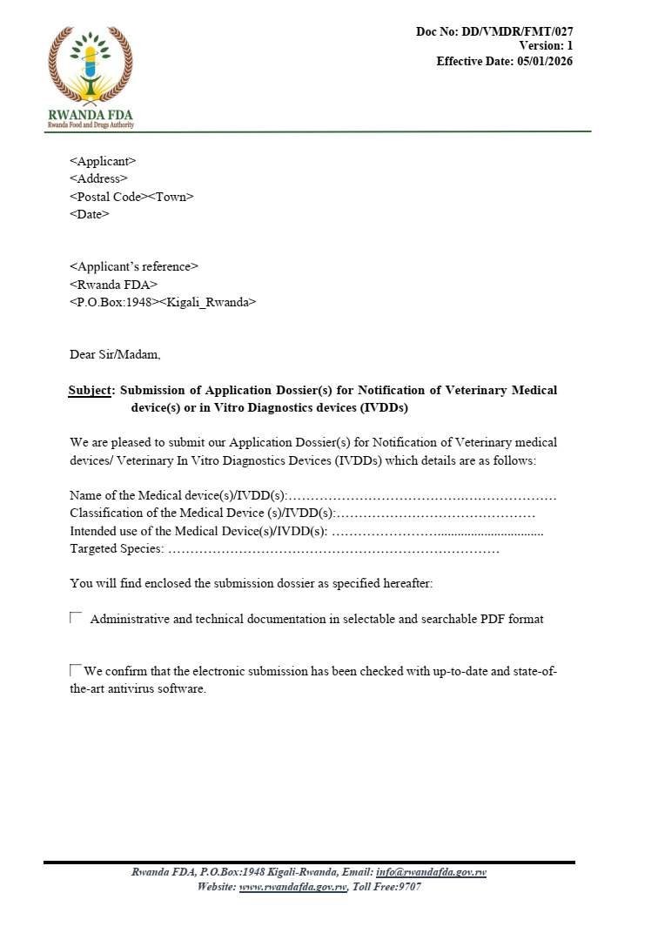

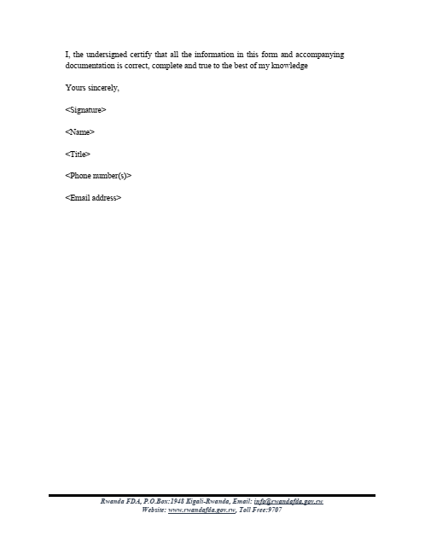
Annex II: Notification Application Form of Veterinary Medical devices and /or In Vitro Diagnostics Devices (IVDD).

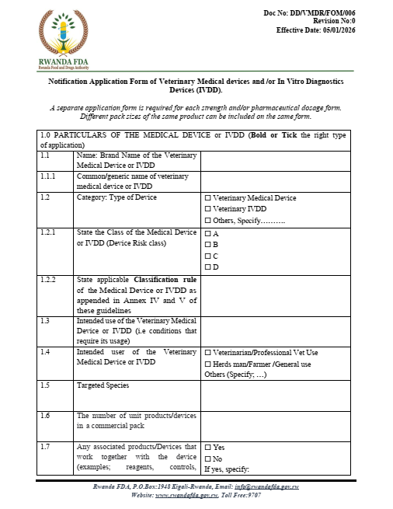

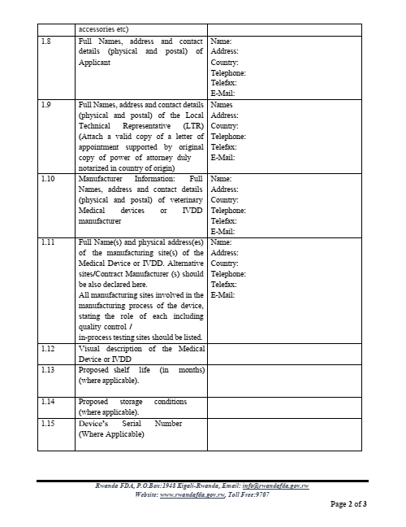

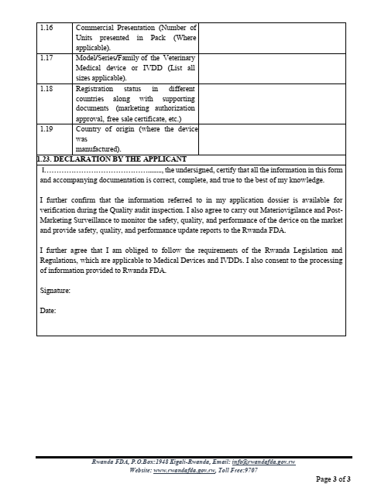

Annex III: Medical Device Classification Rules.

The actual classification of each device depends on the claims made by the manufacturer and on its intended use. While the provision of illustrative examples in the table that follows is helpful when interpreting the purpose of each rule, it must be emphasized that the actual classification of a particular device must be considered individually, taking account of its design and intended use (GHTF/SG1/N15:2006: The Global Harmonization Task Force- Principles of Medical Devices Classification)

Duration of use:
Transient: Normally intended for continuous use for less than 60 minutes.
Short term: Normally intended for continuous use for between 60 minutes and 30 days.
Long term: Normally intended for continuous use for more than 30 days.

NON-INVASIVE DEVICES
RULES |  | ILLUSTRATIVE EXAMPLES
Rule 1. All non-invasive devices which come into contact with injured skin: |  | Devices covered by this rule are extremely claim sensitive.
are in Class A if they are intended to be used as a mechanical barrier, for compression or for absorption of exudates only, i.e. they heal by  primary intent; |  | Examples: bandages; cotton wool.
are in Class B if they are intended to be used principally with wounds which have breached the dermis, including devices principally intended to manage the microenvironment of a wound. |  | Example: non-medicated impregnated gauze dressings.
 | unless they are intended to be used | Devices used to treat wounds where the subcutaneous
 | principally with wounds which have | tissue is at least partially exposed and the edges of the
 | breached the dermis and can only heal by | wound are not sufficiently close to be pulled together.
 | secondary intent, in which case they are in | To close the wound, new tissue must be formed within
 | Class C. | the wound prior to external closure. The device
 |  | The manufacturer claims that they promote healing through
 |  | physical methods other than „primary intent‟.
 |  | Examples: dressings for chronic ulcerated wounds;
 |  | dressings for severe burns.

Rule 2(i). All non-invasive devices intended for channelling or storing  - liquids, or  - gases  for the purpose of eventual infusion administration or introduction into the body are in Class A, | Such devices are „indirectly invasive‟ in that they channel or store liquids that will eventually be delivered into the body.  Examples: administration sets for gravity infusion; syringes without needles
unless they may be connected to an active medical device in Class B or a higher class, in which case they are Class B; | Examples: syringes and administration sets for infusion pumps; anaesthesia breathing circuits.  Note: “Connection” to an active device covers those circumstances where the safety and performance of the active device is influenced by the non-active device and vice versa.
Rule 2(ii). All non-invasive devices intended to be used for  - channeling blood, or  - storing or channeling other body liquids, or storing organs, parts of organs or body tissues, for the  purpose of eventual infusion,  - administration or introduction into the body are Class B. | Examples: tubes used for blood transfusion, organ storage containers
unless they are blood bags, in which case  they are Class C. | Examples: Blood bags that do not incorporate an anti-coagulant.  Note: In some jurisdictions, blood bags have a special rule that places them within a different class.
Rule 3. All non-invasive devices intended for modifying the biological or chemical composition of  - blood,  - other body liquids, or  - other liquids,  intended for infusion into the body are in Class C, | Such devices are „indirectly invasive‟ in that they treat or modify substances that will eventually be delivered into the body. They are normally used in conjunction with an active device within the scope of either Rule 9 or 11.  Examples: hemodialyzers  Note: For the purpose of this part of the rule  modification‟ does not include simple mechanical filtration or centrifuging which are covered below:
unless the treatment consists of filtration, centrifuging or exchanges of gas or of heat, in which case they are in Class B. | Examples: Devices to remove carbon extracorporeal circulation system
Rule 4. All other non-invasive devices are in Class A. | These devices either do not touch the patient or contact intact skin only.  Examples: urine collection bottles; compression hosiery; non-invasive electrodes, hospital beds.
INVASIVE DEVICES
RULE | ILLUSTRATIVE EXAMPLES
Rule 5. All invasive devices with respect to body orifices? (other than those which are surgically invasive) and which:  - are not intended for connection to an active medical device, or  - are intended for connection to a Class A medical device only. | Such devices are invasive in body orifices and are not surgically invasive (refer to definition in Section 4). Devices tend to be diagnostic and therapeutic instruments used in ENT, ophthalmology, dentistry, proctology, urology and gynaecology. Classification depends on the duration of use and the sensitivity (or vulnerability) of the orifice to such invasion.
5.3.are in Class A if they are intended for transient use; | Examples: examination gloves; enema devices.
5.4.are in Class B if they are intended for short-term use; | Examples: urinary catheters, tracheal tubes.
unless they are intended for short-term use in the oral cavity as far as the pharynx, in an ear canal up to the ear drum or in a nasal cavity, in  which case they are in Class A, | Examples: dressings for nose bleeds.
1. are in Class C if they are intended for long-term use; | Example: urethral stent; contact lenses for long-term continuous use (for this device, removal of the lens for cleaning is considered as part of the continuous use).
unless they are intended for long-term use in the oral cavity as far as the pharynx, inan ear canal up to the ear-drum or in a nasal cavity and are not liable to be absorbed by the mucous membrane, in which case they are in  Class B. | Examples: orthodontic materials, removable dental prosthesis.
All invasive devices with respect to body orifices (other than those which are surgically invasive) that are intended to be connected to an active medical device in  Class B or a higher class, are in Class B. | Examples: tracheal tubes connected to a ventilator; suction catheters for stomach drainage; dental aspirator tips.  Note: Independent of the time for which they are  invasive.
Rule 6. All surgically invasive devices intended for transient use are in Class B, | A majority of such devices fall into several major groups: those that create a conduit through the skin (e.g. syringe needles; lancets), surgical instruments (e.g. single-use scalpels; surgical staplers; single-use aortic punch); surgical gloves; and various types of  catheter/sucker etc.
unless they are reusable surgical instruments, in which case they are in Class A; or | Examples: Manually operated surgical drill bits and saws.  Note: A surgical instrument connected to an active  device is in a higher class
unless intended to supply energy in the form of ionizing radiation, in which case they are  in Class C; or | Example: catheter containing sealed radioisotopes.
unless intended to have a biological effect or be wholly or mainly absorbed, in which case they are in Class C; or | Notes: (a) The „biological effect‟ referred to is an intended one than unintentional. The term  „absorption‟ refers to the degradation of a material within the body and the metabolic elimination of the resulting degradation products from the body.  (b) This part of the rule does not apply to those substances that are excreted without modification from the body.  Example: Insufflation gases for the  abdominal cavity.
unless intended to administer medicinal products by means of a delivery system, if this is done in a manner that is potentially hazardous taking account of the mode of application, in which they are in Class C; or | Example: insulin pen for self- administration.  Note: The term „administration of medicines‟ implies storage and/or influencing the rate/volume of medicine delivered not just channeling. The term „potentially hazardous manner‟ refers to the characteristics of the  device and not the competence of the user.
unless they are intended specifically for use in direct contact with the central nervous system in which case they are in Class D; or | Example: spinal needle.
unless intended specifically to diagnose, monitor or correct a defect of the heart or of the central circulatory system through direct contact with these parts of the body, in which  case they are in Class D. | Examples: angioplasty balloon catheters and related guide wires; dedicated disposable cardiovascular surgical instruments.
Rule 7. All surgically invasive devices intended for short-term use are in Class B, | Such devices are mostly used in the context of surgery or post-operative care, or are infusion devices, or are catheters of various types.  Examples: infusion cannulae; temporary filling materials; non-absorbable skin closure devices; tissue stabilizers used in cardiac surgery.  Note: Includes devices that are used during cardiac  surgery but do not monitor or correct a defect.
unless they are intended to administer  medicinal products, in which case they are in Class C; or | Note: The term „administration of medicines‟ implies  storage and/or influencing the rate/volume of medicine delivered not just channeling.
unless they are intended to undergo chemical change in the body (except if the devices are placed in the teeth), in which case they are in Class C; or | Example: surgical adhesive.
unless they are intended to supply energy in the form of ionizing radiation, in which case  they are in Class C; or | Example: brachytherapy device.
unless they are intended to have a biological effect or to be wholly or mainly absorbed, in which case they are in Class D; or | Example: absorbable suture; biological adhesive. Note: The „biological effect‟ referred to is an intended one rather than unintentional. The term  „absorption‟ refers to the degradation of a material within the body and the metabolic elimination of the  resulting degradation products from the body.
unless they are intended specifically for use in direct contact with the central nervous system in  which case they are in Class D; | Example: neurological catheter.
unless they are intended specifically to diagnose, monitor or correct a defect of the heart or of the central circulatory system through direct contact with these parts of the  body, in which case they are in Class D. | Examples: cardiovascular catheters; temporary pacemaker leads; carotid artery shunts
Rule 8. All implantable devices, and long- term surgically invasive devices, are in Class C, | Most of the devices covered by this rule are implants used in the orthopaedic, dental, ophthalmic, and cardiovascular fields.  Example: maxilla-facial implants; bone plates and screws; bone cement; non- absorbable internal s u t u r es ; p o s t s to secure teeth to the mandibula bone  (without a bioactive coating).
unless they are intended to be placed into the teeth or on prepared tooth structure, in which  case they are in Class B; or | Examples: materials for inlays, crowns, and bridges; dental filling materials.
unless they are intended to be used in direct contact with the heart, the central circulatory system or the central nervous  system, in which case they are in Class D; or | Examples: prosthetic heart valves; cardiovascular stents; pacemaker leads and electrodes; deep brain stimulation electrodes; cerebrospinal catheter.
unless they are intended to be life supporting or life sustaining, in which case they are in Class D; or supporting or life sustaining, in which case
unless they are intended to be active implantable medical devices, in which case they are Class D; or | Example: pacemakers; implantable defibrillators.
unless they are intended to have  biological effect or to be wholly or mainly | Example: implants claimed to be bioactive.
absorbed, in which case they are in Class D; or | Note: Hydroxy-apatite is considered as having biological  effect only if so claimed and demonstrated by the manufacturer.
unless they are intended to administer medicinal products, in which case they are in  Class D; or | Example: subcutaneous infusion ports for long-term use.
unless they are intended to undergo chemical change in the body (except if the devices are placed in the teeth), in which case they are in Class D; or | Example: surgical adhesives intended for long term use.  Note: Bone cement is not within the scope of the  term „chemical change in the body‟ since any change takes place in the short rather than long term.
unless they are breast implants, in which case they are in Class D.

ACTIVE DEVICES
Rule 9(i). All active therapeutic devices intended to administer or exchange energy are in Class B, | Such devices are mostly electrically powered equipment used in surgery; devices for specialised treatment and some stimulators.  Examples: muscle stimulators; powered dental hand  pieces; hearing aids; neonatal phototherapy equipment; ultrasound equipment for physiotherapy.
unless their characteristics are such that they may administer or exchange energy to or from the human/Animal body in a potentially hazardous way, including ionizing radiation, taking account of the nature, the density and site of application of the energy, in which case they are in Class  C. | Examples: lung ventilators; baby incubators; electrosurgical generators; external pacemakers and defibrillators; surgical lasers; lithotriptors; therapeutic X-ray and other sources of ionizing radiation.  Note: The term „potentially hazardous‟ refers to the type of technology involved and the intended application.
Rule 9(ii). All active devices intended to control or monitor the performance of active therapeutic devices in Class C, or intended directly to influence the performance of  such devices, are in Class C. | Examples: external feedback systems for active therapeutic devices.
Rule 10(i). Active devices intended for diagnosis are in Class B: | Such devices include equipment for ultrasonic diagnosis/imaging, capture of physiological signals.
10.1. if they are intended to supply energy which will be absorbed by the Animal/human body (except for devices used solely to illuminate the patient's body, with light in the visible or near infra-red spectrum, in which  case they are Class A), or | Examples: magnetic resonance equipment; diagnostic ultrasound in non- critical applications; evoked response stimulators.
10.2. if they are intended to image in vivo  distribution of radiopharmaceuticals, or | Example: gamma/nuclear cameras.
10.3. if they are intended to allow direct diagnosis or monitoring of vital physiological  processes, | Example: electronic thermometers, stethoscopes and blood pressure monitors; electrocardiographs.

unless they are specifically intended for:  - monitoring of vital physiological parameters, where the nature of variations is such that it could result in immediate danger to the patient, for instance variations in cardiac performance, respiration, activity of central nervous system, or  - diagnosing in clinical situations wherethe patient is in immediate danger, in which case they are in Class C. | Example: monitors/alarms for intensive care; biological sensors; oxygen saturation monitors; apnoea monitors.  Example: ultrasound equipment for use in interventional cardiac procedures.
Rule 10. Active devices intended to emit ionizing radiation and intended for diagnostic and/or interventional radiology, including devices which control or monitor such devices, or those which directly influence  their performance, are in Class C. | Example: devices for the control, monitoring or influencing of the emission of ionizing radiation.
Rule 11. All active devices intended to administer and/or remove medicinal products, body liquids or other substances to or from the body are in Class B, | Such devices are mostly drug delivery systems or anaesthesia equipment.  Examples: suction equipment; feeding pumps; jet injectors for vaccination; nebuliser to be used on conscious and spontaneously breathing patients where failure to deliver the appropriate dosage characteristics  is not potentially hazardous.
unless this is done in a manner that is potentially hazardous, taking account of the nature of the substances involved, of the part of the body concerned and of the mode and route of administration, in which case they are  in Class C. | Examples: infusion pumps; anaesthesia equipment; dialysis equipment; hyperbaric chambers; nebuliser where the failure to deliver the appropriate dosage characteristics could be hazardous.
Rule 12. All other active devices are in Class A. | Examples: examination lamps; surgical microscopes; powered hospital beds & wheelchairs; powered equipment for the recording, processing, viewing of  diagnostic images; dental curing lights.
ADDITIONAL RULES

Rule 13. All devices incorporating, as an integral part, a substance which, if used separately, can be considered to be a medicinal product, and which is liable to act on the animal/human body with action ancillary to that of the devices, are in Class D. | These medical devices incorporate medicinal substances in an ancillary role.  Examples: antibiotic bone cements; heparin-coated catheters; wound dressings incorporating antimicrobial agents to provide ancillary action on the wound; blood bags incorporating an anti-coagulant.
Rule 14. All devices manufactured from or incorporating animal or human cells/tissues/derivatives thereof, whether  viable or non-viable, are in Class D, | Example: porcine heart valves.
unless such devices are manufactured from or incorporate non-viable animal tissues or their derivatives that come in contact with intact skin only in which case they are in  Class A. | Examples: leather components of orthopaedic appliances.
Rule 15. All devices intended specifically to  be used for sterilising or disinfecting medical devices are in Class B. | Example: desk-top sterilisers for use with dental instruments.
unless they are disinfectant solutions or washer-disinfectors intended specifically for invasive medical devices, as the end point of processing, in which case they are in Class C; or | Examples: solutions intended to be used for the disinfection of medical devices without further processing (for example in a sterilizer) including those where the infective agent is a prion; washer-disinfector equipment specifically for disinfecting an endoscope or  another invasive device.
unless they are intended to clean medical devices by means of physical action only, in which case they are in Class A.

Rule 16. All devices that are intended specifically to be used for disinfecting, cleaning, rinsing or, when appropriate,  hydrating contact lenses are in Class C. | Note: In some jurisdictions such products: are considered to be outside the scope of the medical device definition; may be subject to different controls.
Rule 17. All devices used for contraception or the prevention of the transmission of sexually transmitted diseases are in Class C, | Examples: contraceptive diaphragms. condoms;
unless they are implantable or long-term invasive devices, in which case they are | Example: contraceptive intrauterine device.
in Class D.

Annex IV: Classification rules of In-vitro diagnostics devices

Rule 1: | IVDDs intended for the following purposes are classified as Class D:  - Devices intended to be used to detect the presence of, or exposure to, a transmissible  agent in blood, blood components, cells, tissues or organs or any of their derivatives, in order to assess their suitability for transfusion, transplantation or cell  administration.  - Devices intended to be used to detect the presence of, or exposure to, a transmissible  agent that causes a life-threatening, disease with a high or suspected risk of propagation;  Rationale: The application of this rule as defined above should be in accordance with the rationale that follows: Devices in this Class are intended to be used to ensure the safety of blood and blood components for transfusion and/or cells, tissues and organs for transplantation. In most cases, the result of the test is the major determinant as to whether the donation/product will be used. Serious diseases are those that result in death or long-term disability, that are often incurable or require major therapeutic interventions and where an accurate diagnosis is vital to mitigate the public health impact of the condition.  Examples: Tests to detect infection by HIV, HCV, HBV, HTLV; HIV blood donor screening and HIV blood diagnostics. This rule applies to first-line assays, confirmatory assays, and supplemental assays.
Rule 2: | IVDDs intended to be used for blood grouping, or to determine foetomaternal blood group incompatibility, or tissue typing to ensure the immunological compatibility of blood, blood grouping for cell administration, blood components, cells, tissue, or organs that are intended for transfusion or transplantation, are classified as Class C, except when intended to determine the presence of the antigen or antibody for any of the following markers:  ABO system [A (ABO1), B (ABO2), AB (ABO3)], Rhesus system [RH1 (D), RH2 (C), RH3 (E), RH4 (c), RH5 (e), and weak or partial Rh(D)], Kell system [Kel1 (K)], Kidd system [JK1 (Jka), JK2 (Jkb)]; or Duffy system [FY1 (Fya), FY2 (Fyb)], in which case they are classified as Class D.  Rationale: The application of this rule as defined above should be in accordance with the rationale for this rule, which is as follows: A high individual risk, where an erroneous result would put the patient in an imminent life-threatening situation, places the device into Class D. The rule divides blood-grouping devices into two subsets, Class C or D, depending on the nature of the blood group antigen the IVD medical device is designed to detect, and its importance in a transfusion setting.  Examples: HLA, Rhesus system, Duffy system (other Duffy systems except those
Rule 3: | IVDDs are classified as Class C if they are intended for use:  - In detecting the presence of, or exposure to, a sexually transmitted agent. Examples: Sexually transmitted diseases, such as Chlamydia trachomatis, Neisseria gonorrhoeae.  - In detecting the presence in cerebrospinal fluid or blood of an infectious agent with a risk of limited propagation.  Examples: Neisseria meningitidis or Cryptococcus neoformans.  - In detecting the presence of an infectious agent, if there is a significant risk that an erroneous result would cause death or severe disability to the individual, foetus or embryo being tested or to the individual`s offspring.  Examples: diagnostic assay for CMV, Chlamydia pneumoniae, Methicillin Resistant Staphylococcus aureus.  - In pre-natal screening of women in order to determine their immune status towards transmissible agents.  Examples: Immune status tests for Rubella or Toxoplasmosis.  - In determining infective disease status or immune status, and where there is a risk that an erroneous result will lead to a patient management decision resulting in an imminent life-threatening situation or severe disability for the patient or for the patient`s offspring.  Examples: Enteroviruses, CMV and HSV in transplant patients.  - In screening for selection of patients for selective therapy and management as companion diagnostics  - In screening, diagnosis or staging of cancer;  Examples: PSA, CEA, and CA 125.  Note: those IVDDs where the therapy decision would usually be made only after further investigation and those used for monitoring would fall into class B under rule 6.  - In human genetic testing  Examples: Huntington’s Disease, Cystic Fibrosis.  - To monitor levels of medicines, substances or biological components, when there is a risk that an erroneous result will lead to a patient management decision resulting in an immediate life-threatening situation for the patient or for the patient`s offspring. Examples: Troponin, Cyclosporin, Prothrombin time testing.  - In the management of patients suffering from a life-threatening disease or condition. Examples: HBV monitoring marker, HCV viral load, HIV Viral Load and HIV and HCV geno- and subtyping  - In screening for congenital disorders in the foetus or embryo.  Examples: Spina Bifida, Down Syndrome, Glucose-6-Phosphate Dehydrogenase Deficiency, and Tay-Sachs disease.  - In screening for congenital disorders in new-born babies where failure to detect and treat such disorders could lead to life-threatening situations or severe disabilities.  Rationale: The application of this rule as defined above should be in accordance with the rationale for this rule, which is as follows: devices in this Class present a moderate public health risk, or a high individual risk, where an erroneous result would put the patient in an imminent life-threatening situation, or would have a major negative impact on outcome. The devices provide the critical, or sole, determinant for the correct diagnosis and monitoring. They may also present a high individual risk because of the stress and anxiety resulting from the information and the nature of the possible follow-up measures.
 | listed in the rule as Class D are in Class C).
Rule 4: | IVDDs intended for use by lay users (such as for self-testing or nearpatient testing) are classified as Class C, except: those devices from which the result is not determining a critical situation, in which case they are classified under Class B, and those devices which are classified under Class D by Rule 1 and/or Rule 2. Rationale: The application of this rule as defined above should be in accordance with the rationale for this rule, which is as follows: in general, these devices may be used by lay user.  Example for self-testing class C: Blood glucose monitoring.  Example for self-testing class B: Pregnancy self-test, fertility testing, and urine test strips.
Rule 5: | The following IVDDs are classified as Class A:  - Reagents or other articles, which possess no critical characteristics intended by the manufacturer to make them suitable for in vitro diagnostic procedures related to a specific examination;  - Instruments intended by the manufacturer specifically to be used for in vitro diagnostic procedures.  - Specimen receptacles.  Note 1: Any product for general laboratory use which is not specifically intended by the manufacturer to be used in in vitro diagnostic applications is not deemed to be an IVDD, as defined in this document.  Rationale: The application of this rule as defined above should be in accordance with the rationale for this rule which is as follows: these devices present a low individual risk and no or minimal public health risk.  Examples: General culture media (excluding the dehydrated powders which are considered not to be a finished IVDD), wash solutions, plain urine cup, and microbiological specimen collection devices.  Note 2: The performance of software or an instrument that is specifically required to perform a particular test will be assessed at the same time as the respective reagent(s).
Rule 6: | IVDDs not covered in Rules 1 through 5 are classified as Class B.  Rationale: The application of this rule as defined above should be in accordance with the rationale for this rule which is as follows: These devices present a moderate individual risk as they are not likely to lead to an erroneous result that would cause death or severe disability, have a major negative impact on patient outcome or put the individual in immediate danger. The devices give results that are usually one of several determinants. If the test result is the sole determinant, but other information is available, such as presenting signs and symptoms or other clinical information, which may guide a physician, classification into Class B may be justified. Other appropriate controls may also be in place to validate the results. This Class also includes those devices that present a low public health risk because they detect infectious agents that are not easily propagated in a population.  Examples: Blood gases, H. pylori test, physiological markers such as hormones, vitamins, and enzymes, metabolic markers, specific IgE assays and celiac disease markers, and tests for anti-nuclear antibody, sex hormone-binding globulin (SHBG), blood urea nitrogen (BUN), aspartate aminotransferase (AST), alkaline phosphatase (ALP), creatinine and HbA1c.
Rule 7: | IVDDs that are controls without a quantitative or qualitative assigned value will be classified as Class B.  Rationale: For such controls, the qualitative or quantitative value is assigned by the user and not the manufacturer.  Examples: Urinalysis controls and chemistry controls.

Annex V: Contents of veterinary medical device and/or IVDD description, instruction for use, device labels, device art work; product leaflet or catalogue

Veterinary medical device and/or IVDD description

Device Description The following descriptive information for the device should be submitted:
a) A general description including its intended use/purpose.
b) The intended patient population and medical condition to be diagnosed and/or treated and other considerations such as patient selection criteria.
c) Principles of operation.
d) Risk class and the applicable classification rule according to the Regulations for Classification and Registration of Medical Devices.
e) An explanation of any novel features.
f) A description of the accessories, other medical devices and other products that are not medical devices, which are intended to be used in combination with it.
g) A description or complete list of the various configurations/variants of the device that will be made available.
h) A general description of the key functional elements, e.g. its parts/components (including software if appropriate), its formulation, its composition, its functionality. Where appropriate, this will include: labelled pictorial representations (e.g. diagrams, photographs, and drawings), clearly indicating key parts/components, including sufficient explanation to understand the drawings and diagrams.
i) A description of the materials incorporated into key functional elements and those making either direct contact with a human body or indirect contact with the body, e.g., during extracorporeal circulation of body fluids.

Statement of the intended use of the device

The applicant should clearly state the intended use of the device. Depending of the device, the statement should include the following information:
a) What the instrument is intended for and whether the test is qualitative or quantitative;
b) The clinical indication for the test (e.g. if it is for a specific disorder, or a condition or risk factor of interest that the test is intended to detect, define or differentiate);
c) That is detected by the assay (that is, the analytical use of the assay (e.g. the marker or nucleic acid sequence being detected));
d) The function of the product (screening, monitoring, diagnostic or aid to diagnosis, staging or aid to staging of disease);
e) The intended user (laboratory professional, farmer, Veterinary professional/technician, farmer, herds man/cow boy and /or lay person);
f) The intended testing animal species (e.g. Cow, goat, sheep, pigs, poultry, etc.);
g) Whether the device/product is for in vitro use, in vivo use, or other veterinary uses;
h) A general description of the principle of the assay method or instrument principles of operation;
i) A description of all components of the assay (e.g. reagents, assay controls and calibrators) and a description of the reactive ingredients of relevant components (e.g. antibodies, antigens, nucleic acid primers etc.);
j) A description of the specimen collection and transport materials provided with the product or recommended for use;
k) A description of any software to be used with the product;
l) A description or complete list of the various configurations/variants of product that will be made available;
m) Where applicable, a description of the accessories, and other products that are intended to be used in combination with the product but are not provided with the product;
n) Storage conditions, including storage conditions and stability of both the unopened and opened product, and working solutions. Where applicable, these instructions should include such information as conditions of temperature, light, humidity, and other pertinent factors;
o) If the test kit includes sterile accessories, an indication of that condition and any necessary instructions in the event of damage to sterile packaging;
p) If the test kit includes accessories that have been specified by the manufacturer as intended for single-use only, an indication of that statement;
q) Clear instructions on how to perform the assay, including instructions on specimen collection, handling, preparation and storage of reagents, the use of assay calibrators and controls and the interpretation of results;
r) Recommendations for quality control procedures;
s) Clear instructions on the correct usage of any equipment or software that is required for the performance of the assay;
t) Any warning and precautions to be considered related to the use of the assay including but not limited to interpreting the results, the disposal of the assay and/or its accessories (e.g. lancets), to any consumables used with it (e.g. reagents) that may be carcinogenic, mutagenic or toxic, or to any potentially infectious substances of human or animal origin;
u) Any residual risks;
v) Precautions and measures to be taken in the event of performance changes or product malfunction;
w) Limitations of the assay, including information on interfering substances that may affect the performance of the assay;
x) Any requirements for special training or particular qualifications of the assay user;
y) Any requirements for routine maintenance. Include details of frequency of maintenance and who should perform this maintenance (for example: the user, a representative of the manufacturer, or a third party;

Veterinary medical device and/or IVDD’s Labels

- Labelling Requirements

A complete set of labelling for the medical device and/or IVDD, including both immediate and outer container labels, must be provided. Labelling shall be in English, French, and/or Kinyarwanda and presented in a legible, permanent, and prominent manner that can be easily understood by the intended user.

- General Labelling Requirements

Depending on the type of device, the label shall include at minimum the following information:

- Device name –If the name does not uniquely identify the device, an additional identifier such as catalogue number or commodity number;
- Manufacturer details – Name, address, and contact information of the manufacturer and manufacturing site(s);
- Device identifier – Including identifiers for devices that are part of a system, kit, or class;
- Batch/lot or serial number.
- Device contents – Indicate contents if not readily apparent (e.g., size, net weight, volume, number of units, or volume after reconstitution).
- Sterility – The word “Sterile” if sold as sterile;
- Single-use designation – “For Single Use Only” if applicable;
- In vitro diagnostic use – Indicate “For In Vitro Diagnostic Use” or use the appropriate symbol;
- Expiry date – Follow ISO 8601 format (YYYY-MM-DD or YYYY-MM), based on storage instructions;
- Medical conditions, purpose, and performance specifications – Unless self-evident to the user.
Directions for use – Unless not required for safe and effective use;
- Warnings and precautions – Include appropriate danger wording or symbols for hazardous devices (chemical, biological, or radioactive);
- Storage and handling – Conditions needed to maintain stability, including any special handling instructions (e.g., fragile);
- Intended use – Abbreviated statement if not clear from the device name (e.g., “For measurement of plasma glucose concentration”);
- Veterinary use – For devices intended for animals, indicate “For Veterinary Use” or “Device for Veterinary Use Only / For Animal Use Only.”;
- Reagents and components – List all included reagents and components on the outer package label, where applicable;
- Public use devices – Provide specimen labels, promotional materials, and user manuals if sold to the general public.
Note: Requirements that have been described in a respective standard should also be followed when labelling a device. E.g: ISO 18113: In vitro diagnostic medical devices Information supplied by the manufacturer (labelling).

The Device art works.

Provide images of the device in its commercial packaging, ensuring all sides of the device are clearly visible.

Product Information Leaflet / Catalogue (if applicable)

A document from the manufacturer containing essential information about the device, including its identity, intended use, and safe operation. It typically covers the device name, model or reference number, description, intended purpose, instructions for use, indications and contraindications, warnings, precautions, storage conditions, and maintenance or disposal instructions, where applicable.

Annex VI: Letter of approval notification of Veterinary Medical Devices and In Vitro Diagnostics

Recipient’s Name and Full Address
Address
Postal Code
Town
Date

Letter of approval notification of Veterinary Medical Device or In Vitro Diagnostic
Date: ………………
Notification Number: Rwanda DFAR/VMDAR -NC-0000 or VIVDD (for IVDs)

This This letter serves as official approval of notification that the Veterinary Medical Device or In Vitro Diagnostic described below has been added on the list of approved Veterinary Medical Device or In Vitro Diagnostic for notification with the Rwanda Food and Drugs Authority (Rwanda FDA) under the provisions of Law No. 003/2018 of 09/02/2018 establishing the Rwanda FDA and determining its mission, organization, and functioning, as stipulated in Article 3 and Article 8, and in accordance with regulations DFAR/HMDAR/TRG/002 Rev_2. The registration is subject to the conditions outlined in the accompanying documentation.

Device Details:
- Device Name: [Device Name]
- Class of the Device: [Class]
- Brief Intended Use of the Device: [Intended Use Description]
- Intended User of the Device: [Intended User]
- Targeted Species: [Targeted Species]
- Recommended Shelf Life and Storage Statement: [Shelf Life in Months and Storage Instructions]
- Name and Address of the Marketing Authorization Holder: [Name and Address]
- Name and Address of the Manufacturer: [Name and Address]
- Name and Address of the Local Technical Representative: [Name and Address]

This registration confirms that the Veterinary Medical device complies with the regulatory requirements set forth by the Rwanda FDA for approval of notification and This official approval of notification is valid for three (3) years from the date of approval unless otherwise revoked or suspended by the Authority.

For any inquiries or further information, please contact the Rwanda FDA.
Sincerely,

Prof. Emile BIENVENU
Director General

