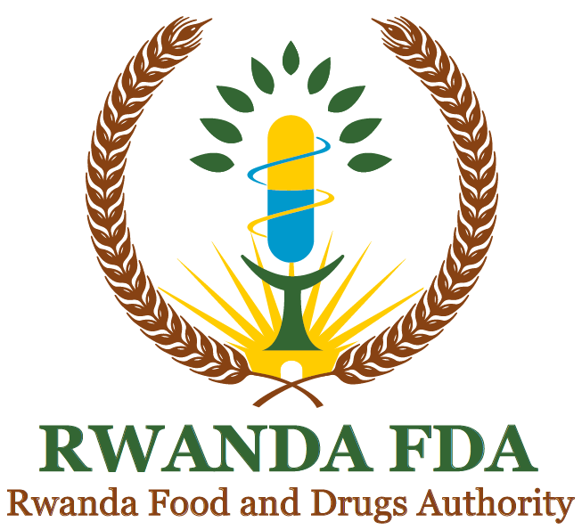

GUIDELINES FOR POST-MARKET SURVEILLANCE OF PROCESSED FOOD PRODUCTS

MARCH 2024

FOREWORD

Food post-market surveillance (PMS) is a feedback mechanism for assessing the safety and quality of processed food products circulating in the market to ascertain compliance after the products’ market authorisation and practices related to that. Surveillance also covers products produced by Food Business Operators who commence operations without Rwanda FDA approval and those who sale, distribute or import products that are substandard or harmful to human being. Surveillance is different from inspection in that surveillance is followed up by timely implementation of appropriate interventions to correct any deviations from the norm. In contrast, inspection aims to catch malpractice and correct accordingly. However, surveillance provides data that enable the assessment of the effectiveness of regulatory measures being enforced, commend good performers, and provide a feedback mechanism to enable those performing poorly to improve.
Rwanda Food and Drugs Authority (Rwanda FDA) mandate is to regulate the quality and safety of food and other regulated products. In view of this, the Authority has established systems and put in place tools for the implementation of its regulatory functions.

To achieve effective food control in the country, Rwanda FDA implements several functions, including food products registration, premises licensing, food establishment’s inspection, food products control at ports of entry, food promotion control, food risk assessment, food contaminants monitoring, disposal of unfit food products, and PMS.

Food PMS is conducted to enable the collection of feedback on the performance of products circulating in the market through systematic monitoring of safety. The system involves taking samples of targeted registered food from the market, submitting samples for laboratory analysis, evaluating the results, and making appropriate interventions. Food PMS also involves customer complaint handling and routine food safety monitoring.

In this context, Rwanda FDA has developed these guidelines on PMS according to Article 9 (10) of Law No 003/2018 of 09/02/2018 to guide consistent monitoring of the safety and quality of regulated food products marketed in Rwanda. Key issues necessary for effective implementation and continuous improvement of food PMS activities have been considered.

This document shall serve as a guide to achieving efficient surveillance of the regulated food products while ensuring effective use of resources to protect public health.

Prof. Emile BIENVENU
Director General

Document Development History

First issue date | 12/03/2024
Effective date of this revision

Document Revision History

Revision number | Changes made and/or reasons for revision
No.:0 | None

TABLE OF CONTENTS

FOREWORD 2
Document Development History 3
Document Revision History 3
TABLE OF CONTENTS 4
ACCRONYMES AND ABBREVIATIONS 5
GLOSSARY / Definitions 6
CHAPTER I. INTRODUCTION 7
1.2 SCOPE………….. 7
CHAPITER II: ORGANISATION OF POST MARKETING SURVEILLANCE SYSTEM 8
CHAPTER III: PLAN FOR IMPLEMENTATION OF FOOD PMS 9
3.2 Sampling 10
3.3 Sample collection, recording, handling, and transportation 10
3.4 Laboratory analysis of samples 10
3.5 Interpretation of results 11
3.6 Dissemination and application of findings 11
CHAPTER IV. FOOD PRODUCTS RECALL 11
CHAPTER V. SEIZURE AND DISPOSAL OF UNFIT FOOD PRODUCTS 13
REFERENCES: 14
ANNEXES 1
Annex 1: Form for collection of samples for post-market surveillance of pre-packaged food 1

ACCRONYMES AND ABBREVIATIONS

CODEX | “food code” or Codex Alimentarius (FAO/WHO)
GHP | Good Hygienic Practices
GMP | Good Manufacturing Practices
PMS | Post-Market Surveillance
Rwanda FDA | Rwanda Food and Drugs Authority

GLOSSARY / Definitions

For the purpose of these guidelines, the following definitions shall apply.
- Authority: refers to the Rwanda Food and Drugs Authority or its acronym “Rwanda FDA”, established by Law N° 003/2018 of 09/02/2018
- Director General: means the Director General of Rwanda FDA.
- Distributor: means a person or organization who receives, stores, warehouses, handles, holds, offers, markets or displays processed foods and related products. A distributor shall be an entity that is appropriately authorized by the competent authority to perform the intended function as prescribed in these Regulations, and which can be held accountable for its activities. These include but not limited to governments at all levels, public and private processed food handlers and storage facilities, manufacturers of finished products, importers, exporters, distributors, wholesalers, suppliers, retailers.
- Food fraud: is a collective term used to describe deliberate and intentional malicious substitution, addition, tampering, or misrepresentation of food, food ingredients, or food packaging; false or misleading statement made about a food product for economic gain.
- Food recall: A process for withdrawing or removing a product from the distribution chain because of defects in the product, consumer complaints of serious adverse reactions to the product and/or concerns that the product is or may be counterfeit.
- Food withdrawal: is an action taken to remove food from the supply chain when there is food safety risk, or the food safety risk has not yet been confirmed.
- Food product: means any animal or plant products that have been processed or transformed from their original state and are intended for human or animal consumption with the exception of pharmaceutical products, tobacco, food additives and food fortificant. These may be products including but not limited to any powders, liquids, fruits, vegetables, grains, minerals, or commercially produced foods made for human or animal consumption.
- Inspector: means any officer appointed, authorized or recognized under the Law Nº 003/2018 of 09/02/2018.
- Premises: means any plot of land, buildings or boats, aircrafts, vehicles, a part of a building, channels, yards, a place of storage, annexed to a building, or part of that building, carriage or receptacle of any kind, whether open or closed, intended for manufacturing, storing, exhibit, wholesale or retail activities of food products and related products.
- Traceability: means the ability to track a food through all stages of production, processing, and distribution (including importation and retail). Traceability implies that movements can be traced one step backward and one step forward at any point in the supply chain.
- Unsafe food: is food that may cause illness or physical harm to a person who consumes it (e.g., it contains pathogenic microorganisms at potentially harmful levels, chemical or physical hazards, or an undeclared allergen).

CHAPTER I. INTRODUCTION

The general population is exposed to various food safety hazards, such as chemical, microbial, and physical hazards and allergens. Before they are placed on the market, processed food products (pre-packaged food) are tested for these food safety hazards through the registration process. Therefore, the objective of food registration is to safeguard public health by ensuring that all processed foods meet national, regional, or international standards. Once the processed food is registered after complying with safety and quality requirements as per the standard of the particular food product, it is allowed to be placed on the market. Once in the market, the processed food product needs to be monitored to make sure that it continues to comply with safety and quality requirements. If Good Hygienic Practices (GHP) or Good Manufacturing Practices (GMP) are not fully implemented during the manufacture of food products, it can result into food products failing to comply with prescribed food safety requirements and subject consumers to an unacceptable level of risk. Therefore, PMS supports regulatory inspections, which are the key instrument for the Rwanda FDA to control compliance with set standards, laws, and regulations and enforce them.

Therefore, the main objective of PMS is to monitor how regulated food products released to the market for human consumption adhere to the established safety specifications at any point in time and propose strategies to address any shortcoming identified. The Rwanda FDA must conduct and maintain a market surveillance system for the purpose of ensuring that illegally imported and unsafe processed food products are not allowed to be put on or remain on the market to ensure public health and fair market conditions.
Specific objectives, such as food safety hazards to be monitored on the market, should be included when developing a food PMS program. The food PMS program could be for three years and could be reviewed on yearly basis to include new areas as influenced by new developments that reveal food safety issues that need immediate attention or increased capacity to broaden the scope of PMS.
As such, this guidance document was developed to guide the development of a food PMS program for processed food products.

SCOPE
These guidelines cover all processes with regard to the post-market surveillance of processed food products; through risk assessment, risk management and risk communication framework to prevent food frauds and other health-related impacts of consumption of unsafe and poor quality products. Safety and quality of both locally manufactured and imported food products are assessed to ensure compliance to their respective standards.

1.3 Purpose of the guidelines
The purpose of these guidelines is to establish a PMS system, develop a PMS plan, implement the plan and generate report for PMS activities for food products. Effective implementation of PMS guidelines will enable the Authority to generate scientific evidence on the quality and safety of food products.

  - OBJECTIVES OF POST MARKETING SURVEILLANCE

1.4.1 General Objectives

Post-marketing surveillance of food product is implemented to protect the public health by early detecting, preventing and removing non-compliant food products and taking appropriate regulatory actions.

    - Specific objectives

PMS activities are carried out to:
- Evaluate the quality of food products available throughout the supply chain,
- Identify gaps in food safety system.
- Prevent non-compliant products from entering further into the supply chain,
- Initiate actions to address the root cause of non-compliant products,
- Remove non-compliant food products from the market.

CHAPITER II: ORGANISATION OF POST MARKETING SURVEILLANCE SYSTEM

- Strategies for Post-Marketing Program

The Authority’s strategies for PMS system shall include but not limited to the following:
- Conducting Post market surveillance inspection for food products available on market.
- Receiving reports and complaints on suspected poor quality food products and conducting deep investigation on received reports and complaints.
- Sampling and testing of products available in the supply chain of food products.
- Take appropriate regulatory action as result of PMS activities

  - PMS program structure, roles and responsibilities

The structure of PMS program is composed with the Authority including Post Marketing Surveillance technical committee and PMS stakeholders with the following role and responsibilities:

    - Regulatory Authority

The Authority coordinates all post-marketing surveillance activities through respective divisions and units which include but not limited to the following:
- Conducting Post market surveillance inspection for food products available on market,
- Conducting post market sampling of suspected poor quality food products,
- To provide evidence-based test results to inform regulatory action against identified substandard products,
- To develop sampling protocol, plan, and determine sampling priorities,
- To report on PMS activities,
- To inspect the implementation of a regulatory action taken like product recalls and products in quarantine,
- To analyse and follow up on reports related to suspected poor quality food products,
- To take and implement appropriate regulatory actions as results of PMS activities,
- Monitor regulatory actions taken as a results of PMS findings,
- Conducting bi-annual random sampling of food products country-wide,
- Taking regulatory actions on non-compliant food products.

    - Post Marketing Surveillance stakeholders

The PMS stakeholders include Ministry of Health, Regional and International Organisations (WHO, INFOSAN, WTO,…), food industries, media, security organs such as Rwanda National Police (RNP) and Rwanda Investigation Bureau (RIB), Rwanda Revenue Authority (RRA), Ministry of Trade and Industry, local government etc.

All PMS stakeholders have the responsibilities which include but not limited to the following:

- To report any suspected or confirmed poor quality food product to the Authority using official communication channels.
- To implement any regulatory action taken by the Authority as result of PMS activities;
- To conduct joint inspections where necessary.

CHAPTER III: PLAN FOR IMPLEMENTATION OF FOOD PMS

A plan for PMS implementation shall be developed. This include identifying foods for surveillance and parameters to be analyzed, the provinces and districts where processed food is monitored, the timeframe for implementation of the food PMS program (e.g., three financial years), how the sampling is conducted, the stakeholders involved (i.e., Food Department and Laboratory Services Departments), and the registrants of the processed food.

3.1 Post market surveillance inspections.
Different forms of post market surveillance inspection are conducted and they include the following:
- Planned routine food safety monitoring inspections,
- Inspections following up the reported cases,
- Joint operations with other government institutions,
- Post market sampling of food products country wide.

During post market surveillance inspections suspected poor quality and/or sub-standard food products can be found. Those products include: fraudulent, falsified, counterfeited, sub-standard, expired and recalled food products.

- In case of Fraudulent, falsified, counterfeited food products other public institutions are jointly involved with Rwanda FDA inspectors during investigation. The public institutions involved include Rwanda Investigation Bureau, Rwanda National Police, Rwanda Revenue Authority and Local government.
- Suspected poor quality food products shall be quarantined, confiscated while investigation is being conducted. Where sampling will be deemed necessary the Authority shall not be liable for any product related cost
- Sub-standard and prohibited food product shall be disposed of after risk assessment and the owners will be fined in accordance to Rwanda FDA regulations.

Sampling

A PMS sampling schedule shall be developed that takes into consideration provinces and districts where sampling would be undertaken and months for conducting the survey, among other things. Sampling will take into consideration specifications set in the national and international standards for the respective product.

3.3 Sample collection, recording, handling, and transportation
- Samples for pre-packaged food products shall be collected in their original containers or in appropriate sampling containers or bags. In case a product needs to be sub-sampled, the food inspector shall ensure that all information on the original container is properly recorded and the integrity of the sample is maintained.
- An inspector collecting the samples shall assign each sample an identification number and record all necessary information in the form provided in Annex 1. Information in Annex 1 will be used to fill sample submission form that will be submitted to the Quality Control Laboratory.
- Handling and transportation of samples from collection sites to the Laboratory Services Department shall be maintained in good condition to avoid any physical damage that could impact the quality and safety of the product.
- Collected samples shall be stored in a manner that preserves sample and prevents the introduction of agents that may interfere with the analysis results.

3.4 Laboratory analysis of samples
- Each sample should be analysed for the prescribed parameters as per methods of testing prescribed in the respective product standard or any other relevant method. Depending on available resources, analysis of food should largely be limited to parameters of critical importance to food safety.
- The PMS program shall cover parameters that should be tested for each food product.

3.5 Interpretation of results
Results from the program shall be interpreted based on the product’s national standard for analysed parameters, regional standards, or CODEX standards. The interpretation will link to the levels of risk consumers are exposed to through consumption of the food product.

3.6 Dissemination and application of findings

From implementation of the program a report prepared to serve as the basis for regulatory decisions and recommendation measures to improve food safety. Findings will be shared among the relevant levels at the Rwanda FDA for action and, where necessary, with other stakeholders.

CHAPTER IV. FOOD PRODUCTS RECALL

A food recall is an action taken to remove from distribution, sale, and consumption unsafe food, which is food that may cause illness or other physical harm to a person consuming the food.

The identification of unfit food products is paramount. Food safety inspections play a crucial role in this process. Regular inspections are essential for preventing foodborne diseases and maintaining hygiene standards in food establishments. Rwanda FDA sometimes collaborates with various stakeholders to conduct these inspections, which are vital for identifying food products that do not meet safety standards.
Once unfit food products are identified, these guidelines outline clear procedures for recalling these products. Effective recall procedures are critical for minimizing health risks associated with the consumption of unsafe food. Robust systems for food recall can significantly reduce the incidence of foodborne illnesses. In Rwanda, the establishment of a systematic approach to food recalls, including communication strategies to inform the public and stakeholders, is essential for effective management of food safety crises.
To ensure that unsafe food does not reach final consumers and hence protect public health, food business operators engaged in the manufacture of food must:
1. Have in place a system and procedures to ensure the recall of unsafe food;
2. Set out this system in a written document and make this document available to the Competent Authority on request.

4.1 Responsibilities during a food recall
3.1.1. Food Manufacturer
Food manufacturers have a role in ensuring that the food they produce the regulatory requirements. Therefore, food manufacturers have a legal requirement to have a written food recall plan in place and follow this plan in the event of a recall. The primary responsibility for undertaking the recall of unsafe food lies in the hands of the food manufacturer. Hence, they are responsible for:

- Notifying Rwanda FDA about the recall;
- Establishing and maintaining a food recall plan by using the appropriate documented operational procedures and training their staff to execute the food recall plan;
- Obtaining and consolidating all necessary information about the food product;
- Retrieving the unsafe food from the supply chain and removal from sale;
- Disposing of the food product under supervision of Rwanda FDA and other government agencies;
- Monitoring the effectiveness of the recall;
- Keeping appropriate records;
- Reporting on the recall to Rwanda FDA, including the action taken to prevent a recurrence of the problem.
3.1.2. Rwanda FDA
In the event of recalling unsafe food from the market, Rwanda FDA should be responsible for:

- When appropriate, providing technical advice to the manufacturer to help assess the food safety issue identified;
- In consultation with a manufacturer advising on whether a food product should be recalled;
- If a recall is needed, advising the manufacturer on recall actions and requirements. This may include how the recalled food product is to be collected and disposed of and corrective actions needed.;
- Monitoring the effectiveness of food recalls
- Checking that local food businesses have removed recalled food from sale;
- Disposing of the recalled food, including overseeing the destruction of the food;
- Initiating a recall of unsafe food as a result of an outbreak of food-borne disease
- Cooperating with government agencies at national and international levels;
- Conducting an ongoing food safety investigation, when necessary, to identify additional possibly implicated foods;
- Ordering and enforcing a recall if a food business operator fails to comply with regulatory requirements;
- Ensuring that consumers and customers are informed and that their questions and concerns are managed appropriately;

3.1.3. Triggers
Rwanda FDA shall launch a food safety investigation, which could lead to a mandatory food recall based on several triggers, such as:
- Suspected or confirmed foodborne illness outbreak
- Food test result
- Food inspection finding
- Complaints from consumers, industry, other government institutions or associations
- Company-initiated recall
- Recall in another country
- Food recall alert from INFOSAN

3.1.4 Food Investigation
When dealing with potentially unsafe food, Rwanda FDA shall act as quickly as possible to collect information and make decisions. Food safety investigations should be carried out by Rwanda FDA’s staff under the Department of Food and should continue until complete and sufficient information is gathered to develop a strategy to mitigate the risk.

CHAPTER V. SEIZURE AND DISPOSAL OF UNFIT FOOD PRODUCTS

Seizure and disposal of unfit food products are crucial for ensuring food safety and public health. Where an inspector seizes food, which is unfit for human consumption, or which is suspected of being unfit for human consumption, he/she shall ensure that food product is withdrawn from the market and dealt with appropriately. In any case, an inspector who seizes such food shall issue an appropriate seizure PV de Constat is filled and appropriate actions are taken.

5.1 Procedure for Disposal of Unfit Food
No person shall dispose of any food product without permission and supervision from Rwanda FDA. Approval of application and safe disposal of any food product shall be sought from Rwanda FDA and other relevant Competent Authority.

The applicant shall arrange with the appropriate waste management agency to assist in the destruction. The applicant shall arrange the means of conveyance of the unwholesome products to the site of destruction where necessary, representatives from REMA, City of Kigali and Rwanda National police shall be present as witnesses.

REFERENCES:

Daniel WW (1999). Biostatistics: A Foundation for Analysis in the Health Science. 7th edition. New York: John Wiley & Sons.
Macfarlane SB (1997). Conducting a descriptive Survey: 2. Choosing a Sampling Strategy. Trop Doct, 27 (1): 14–21.
Republic of Rwanda, Ministry of Health. (2019). Rwanda FDA standard operating procedure for food post market surveillance program.
United Republic of Tanzania, Ministry of Health. (July 2017), TFDA Food Post-Market Surveillance Program.

ANNEXES

Annex 1: Form for collection of samples for post-market surveillance of pre-packaged food
(To be completed for each sample)

Province……………………District……….…… Date of sample collection .......................

    - SAMPLE INFORMATION

  - Sample code (PROVINCE/FPMSYY/SN) ...............................................
(Note: Province refers to the abbreviation for a province in Rwanda, FPMSYY refers to Food PMS and year (YY), and SN is the serial number of the sample. For example, NP/FPMS2015/1 would indicate sample number 1 from the Northern Province. The corresponding sample should be labelled with the same number.)
  - Trade or brand name ……………………….............
  - Common name ……………………….............
  - Batch/lot number ...............................................
  - Manufacture date ...............................................
  - Expiry date ...............................................
  - Net content (in weight or volume) .....................................
  - Total number of samples taken...................................................
  - Name and address of manufacturer ...............................................
  - Product form: (a) Solid (b) Liquid c) Other (specify)...................................
  - List of ingredients………………………………………………………………
  - Sample was collected from (a) Original package (b) Bulk
  - Type of packaging material: (a) Suitable for the product (b) Not suitable. If not suitable, explain. .....................................................................

    - DETAILS OF SAMPLING LOCATION

- Name and physical address of premises where sample was collected
........................................................................................................................
- Type of premises: (a) Wholesale (b) Supermarket (c) Retail (d) Open market (e) Other (specify) ....................................………………
- Was the storage condition appropriate for the product? (a) Yes (b) No. If no, explain...........................
- Other observation(s)
…………………………………………………………………………………

Inspector’s name: ……………………………………………………………………………
Signature: ………………………………………Date……………………………………….

Owners name: …………………………………………………………………………

Signature: ………………………………………Date……………………………………….

ENDORSEMENT OF THE GUIDELINES

 | Prepared by | Checked by |  | Approved by
Title | Division manager | Head of Department | QMS Division Manager | Director General
Names
Signature
Date

APPENDICES

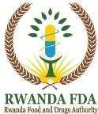
QMS N⁰: DIS/FOM/095
Revision No: 0
Effective Date:20 Jul 2021


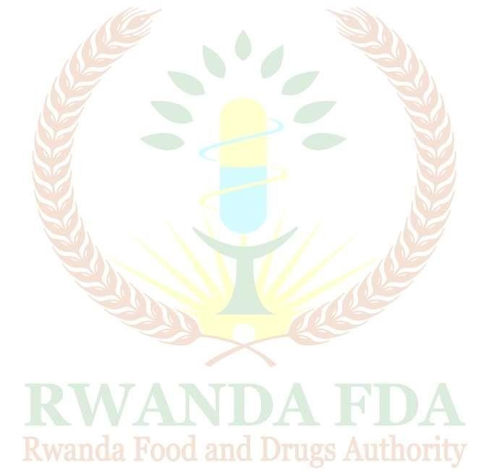
P.O.Box1948Kigali info@rwandafda.gov.rw www.rwandafda.gov.rw

MINUTES/ PV DE CONSTAT
The year two thousand and …….…........, the ……................……. Day of the Month of.............. We…………………………………………………………………………………………………
…………………………………………………………………………………………………………
…………………………………………………………………………………………………………
… Inspector (s) of Pharmaceutical Activities,
went to the Retail Pharmacy / Wholesale pharmacy / Food Supplement Shop/ Optical Shop/ Other (Specify)………………………………………………………………………………………..

Located at…………………………………………………………………………………………..
… in
the Province/ VK, where we met with Mr / Ms (Name and position)
………………………………………………………………………………………

FINDINGS
…………………………………………………………………………………………………………

…………………………………………………………………………………………………………

………………………………………………………………………………………………………………

…………………………………………………………………………………………………………

…………………………………………………………………………………………………………
QMS N⁰: DIS/FOM/095
Revision No: 0
Effective Date:20 Jul 2021

…………………………………………………………………………………………………………

…………………………………………………………………………………………………………

…………………………………………………………………………………………………………

…………………………………………………………………………………………………………

…………………………………………………………………………………………………………

…………………………………………………………………………………………………………

…………………………………………………………………………………………………………

…………………………………………………………………………………………………………
…………………………………………………………………………………………………………

…………………………………………………………………………………………………………

…………………………………………………………………………………………………………

…………………………………………………………………………………………………………

…………………………………………………………………………………………………………
…………………………………………………………………………………………………………

…………………………………………………………………………………………………………

…………………………………………………………………………………………………………

…………………………………………………………………………………………………………

…………………………………………………………………………………………………………

…………………………………………………………………………………………………………

…………………………………………………………………………………………………………

…………………………………………………………………………………………………………

QMS N⁰: DIS/FOM/095
Revision No: 0
Effective Date:20 Jul 2021

Decision (s) taken:
…………………………………………………………………………………………………………
…………………………………………………………………………………………………………
…………………………………………………………………………………………………………
…………………………………………………………………………………………………………
…………………………………………………………………………………………………………
…………………………………………………………………………………………………………
…………………………………………………………………………………………………………
…………………………………………………………………………………………………………

Signatures

For the Establishment | INSPECTORS (Name & Signature)
(Name, Signature and Stamp) | 1.
(Name, Signature and Stamp) | 2.
(Name, Signature and Stamp) | 3.
(Name, Signature and Stamp) | 4.

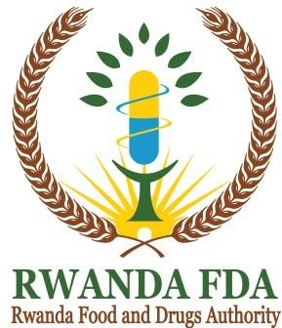
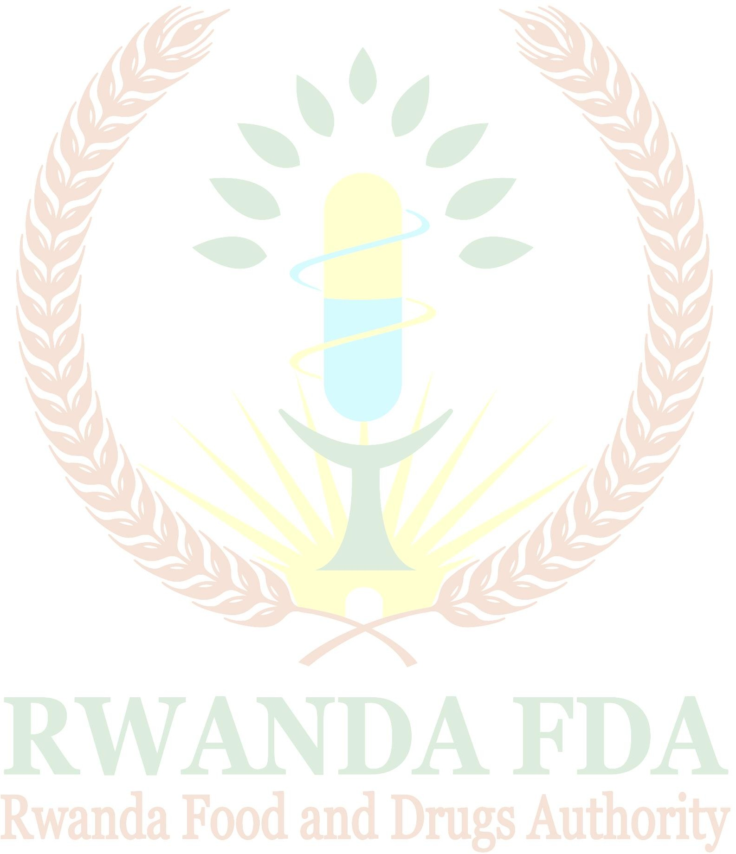
P.O.Box1948Kigali info@rwandafda.gov.rw www.rwandafda.gov.rw

POST MARKETING SURVEILLANCE PROGRAMME SAMPLE COLLECTION FORM
1. Sample code: ...............................................................
(Region/product/sequence number/sampling date......./....../. )
2. Name & Address of Premises where sample was taken: a. Physical Address................................
b. Postal address...............................
c. Telephone No........................ ......................................
d. Email address. (if applicable)
3. Product description of the sample: .........................................
a. Generic name…………………………………….
- Trade or Brand name……………………………….
- Composition/List of ingredient(s) ……………………………………………………
………………………………………………………………………………………………..
- Strength/Concentration/Nutritional values
……………………………………………………………
e. Package size & type: ........................................................
f. Size of the consignment: ……………………………………….
g. Batch/lot number: ........................................................
h. Date of manufacture: ..........................Expiry date………………….
- Name and physical address of the manufacturer: .....................
- Number of units collected (tins, packet, bottles, etc.) ..........................
- Is the product registered in the country? Yes/ No.
  - If Yes, indicate the registration number: ........................
7. Storage condition of product: ............................
8. Parameters to be tested: …………………………………….

SIGNATURE PAGE

For the establishment  (Name, Signature, and Stamp) | INSPECTORS  (Name & Signature)

