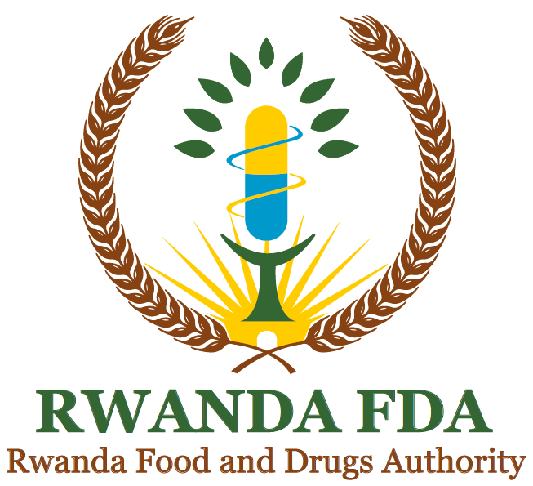

ADDENDUM TO THE REGULATION NO.: CBD/TRG/028 GOVERNING LICENSING TO MANUFACTURE, TO STORE, TO OPERATE AS WHOLESALE AND RETAIL SELLER OF PROCESSED FOODS AND RELATED PRODUCTS

AUGUST, 2024

FOREWORD

Rwanda Food and Drugs Authority (Rwanda FDA) is a regulatory body established by the Law N° 003/2018 of 09/02/2018. One of the functions of Rwanda FDA is to regulate matters related to quality and safety of processed foods.

The Authority has set various regulatory documents to guide the FBOs towards compliance to safety and quality of the food products. One of those regulatory documents is the Regulations No. CBD/TRG//028 governing licensing to manufacture, to store, to operate as wholesale or retail seller of processed foods and related products. Its article 20 on administrative sanctions highlights 9 offences whereby fines shall apply. However, while conducting inspections it was noted that some offenses did not exist by the time of setting the regulations.

This addendum therefore highlights the offenses that have been observed and their respective administrative sanctions/ fines and procedures to be followed during joint inspections.

The Authority may amend this addendum as need arises in order to ensure that new malpractices are sanctioned.

Prof. Emile BIENVENU
Director General

Document DEVELOPMENT HISTORY

First issue date

Effective date of this revision

Document Revision History

Revision number | Changes made and/or reasons for revision

proper definition of substandard AND EXAMPLES

Repeated violation: The Authority shall cancel, suspend or withdraw a license of a facility if the facility contravenes following licensing requirements: 1⁰ Any of the conditions under which the license was issued no longer exist, 2⁰ The information on which the approval was given is later found to be false, 3⁰ The circumstances under which the approval was given no longer exist, 4⁰ Repeated violation of the regulatory administrative sanction or decision.
The table below illustrates the offenses/ faults currently committed by FBOs and their administrative sanctions/ fines:

S/N | FAULT/ OFFENSE | ADMINISTRATIVE SANCTIONS
 | Violation of quarantine | - Closure  - Fine: 500,000
 | Obstruction to inspection team | - Closure  - Law enforcement organs to secure search warrant and execute the search and seizure
 | Dodge inspection team | - Closure  - Fine: 250,000Frw for each day of obstruction
 | Use of non-permitted or untraceable raw materials and/or additives | - Warning letter  - Disposal of the condemned products
 | Use of unsuitable primary packaging materials other than the ones provided for in respective product standard such as plastic bottles for alcoholic beverages | - Closure  - Fine: Double the value of the condemned products
 | Use of packaging materials from other industries | - Warning letter  - Disposal of the condemned products  The owner of property to be alerted so he/ she may claim intellectual property violations
 | Use of unauthorized secondary packaging materials | - Quarantine of products and replacement of packaging material  - Warning letter
 | Excessive poor hygiene in the premises | - Closure for correction until the Authority reopens
 | Products on the market with visible contaminants (live weevils, insects) | - Immediate Disposal  - Fine: Double the value of the condemned products
 | Operating with pending administrative fines beyond payment period | - Closure  - Revocation of license (if applicable)  - RIB to take action
 | Disposal of regulated unfit products without Rwanda FDA supervision | - Fine: 200,000 Frw
 | Transferring/ using a valid license of a licensed premise to or by unlicensed premises. | Fine: 1,000,000 Frw
 | Failure to provide invoices, contracts or any distribution reports detailing the value of non-complying and fraudulent regulated products at the time of inspection | Fine: 500,000 Frw
 | Relocation without notifying the Authority | Fine:100,000 Frw
 | Vehicle transporting substandard products (from an industry without FDA operational license, illegally imported, mislabelled, expired, counterfeits) | - Seize the vehicle and products at nearest station RNP station  - Investigation by RIB to find the products manufacturer/ importer  - Disposal of the condemned products at the owner’s cost  Fine the manufacturer/ importer: double the value of condemned products

ENDORSEMENT OF THE ADDENDUM

 | Prepared by | Checked by |  | Approved by
Title | Division manager | Head of Department | QMS Division Manager | Director General
Names
Signature
Date

